When every risk is material: disclosed risk convergence, documented response and organisational resilience in US firms, 2017 to 2025
Imo J. Enang
Structured abstract
Purpose. This study examines whether the number of emerging strategic risks a firm discloses and the responses it documents identify which firms lose most when systemic shocks arrive.
Design/methodology/approach. A stratified random sample of 787 US non-financial firms supplied 6,214 annual reports for fiscal 2017 to 2025. Nine risk categories were measured in Item 1A and documented responses in Items 1 and 7 under four classifiers audited against a coding manual. Disclosure was linked to SEC financial data and to uncertainty indices. Pre-registered models with small-cluster inference examine the pandemic and the 2022 shocks; the first version's results were reproduced from the raw filings.
Findings. Mean convergence breadth rose from 5.06 to 7.83 of nine categories while dispersion across firms fell under every alternative count. Breadth did not predict the pandemic revenue fall; the interval excludes falls above 3.3 per cent per standard deviation. Rule-based response measures had precision near 0.23; threat-linked responses were rare and no measure protected performance. Geopolitical and supply-chain exposure moved revenue and cost together in high-index years while macro-financial exposure lowered margins. Combined exposure added nothing measurable.
Research limitations/implications. Validation labels come from AI coding that awaits human double-coding. Outcomes are nominal and the evidence is associational.
Practical implications. Boards should treat the risk-factor list as a compliance record and assess exposure by transmission channel and by completed action.
Originality/value. The study separates disclosed exposure, documented response and realised sensitivity and shows that disclosure saturation has removed the information in aggregate risk counts.
Keywords. Strategic risk, Risk disclosure, Disclosure saturation, Organisational resilience, Dynamic capabilities, Enterprise risk management, Polycrisis
Paper type. Research paper

Introduction
Boards now read annual reports in which almost every emerging risk is listed as material. In fiscal 2017 the typical sampled US firm discussed 5.06 of nine emerging risk categories at length in its risk factors; by fiscal 2025 the figure was 7.83 with 35.3 per cent of firms covering all nine. The period behind this change brought a pandemic and three extreme index readings: the highest global supply-chain pressure since the index begins in 1998 (December 2021), the highest geopolitical risk since March 2003 (March 2022) and the highest US trade policy uncertainty since 1985 (April 2025) (Benigno et al., 2022; Caldara and Iacoviello, 2022; Baker et al., 2016). Scholars of systemic risk describe such periods as a polycrisis in which crises in different systems entangle and intensify each other (Lawrence et al., 2024; Helbing, 2013; Renn et al., 2019) and survey evidence suggests that firms in global production networks respond mostly with cautious measures such as buffers and scanning (Pedersen et al., 2026; Bag, 2026). Executives face the practical version of the problem when they decide how many risks deserve attention and what to do about each (Day and Dennis, 2022; Sheehan, 2020; Soleimani and Stauffer, 2026).
Two assumptions sit behind current practice. The first holds that firms exposed to several emerging risks at once are more fragile, because shocks that arrive together exhaust attention and slack (Ocasio, 1997; Bourgeois, 1981; Lawrence et al., 2024). The second holds that a firm which documents responses to the risks it discloses is better prepared (Nocco and Stulz, 2006; Hoyt and Liebenberg, 2011). Recent work supports versions of both. Pre-crisis disclosure of slack, learning and innovation capabilities in 10-K filings was associated with investor recognition of resilience during the pandemic (Neunsinger et al., 2026); among Chinese listed firms a closer match between disclosed risks and disclosed responses predicted better subsequent performance (Zhang et al., 2026). Text-based research has otherwise measured one risk at a time: political risk (Hassan et al., 2019), epidemic exposure (Hassan et al., 2023), climate exposure (Sautner et al., 2023; Wang and Li, 2026) or cyber risk (Florackis et al., 2022). Two questions remain open: whether the number and combination of disclosed risks still separate firms once nearly all firms list nearly all risks and whether the responses that classification rules find in annual reports are in fact responses to those risks.
This study addresses both questions with 6,214 annual reports filed by a stratified random sample of 787 US non-financial firms between fiscal 2017 and 2025, linked to SEC financial statement data and to four public uncertainty indices. It asks how far emerging risks co-occur in disclosure, whether pre-shock convergence predicts losses and recovery in the pandemic and the 2022 shocks and whether firms whose documented actions cover their disclosed risks fare better. Hypotheses, measures and decision rules were committed to the project repository before outcomes were merged with text measures and all later changes are dated. Because the response measure carries the second assumption, it was rebuilt from a written coding manual and audited under four classification rules; the whole pipeline was also rerun from the raw filings to confirm every reported number.
The findings challenge both assumptions. Disclosure saturated. Breadth rose towards its ceiling, dispersion across firms fell under every way of counting risks and breadth carried no information about who fell furthest in either shock. Rule-based response measures mostly captured routine treasury, contracting and acquisition activity; responses explicitly tied to a disclosed threat were rare and did not protect performance. Realised sensitivity followed specific channels: geopolitical and supply-chain exposure moved revenue and cost together, macro-financial exposure lowered margins and combined exposure added nothing measurable. The paper contributes to strategic risk management and dynamic capabilities research by separating disclosed exposure, documented response and realised sensitivity and by showing which kinds of risk information remain useful once aggregate counts have saturated. It gives boards a four-stage diagnostic built on that distinction.

Disclosed exposure, documented response and realised sensitivity
Strategic management has long treated environmental uncertainty as a set of separable conditions to be judged one at a time, each with its own likely effect and response (Rindova and Courtney, 2020; Bundy et al., 2017; Dess and Beard, 1984). Enterprise risk management inherited that separability. Its frameworks ask firms to list risks, score each on likelihood and impact and aggregate the scores into a portfolio view (Nocco and Stulz, 2006; Bromiley et al., 2015; Andersen, 2008). Systemic-risk scholars argue that separability misses the defining feature of the current period, in which shocks interact through shared infrastructure, supply networks and policy responses (Helbing, 2013; Renn et al., 2019; Lawrence et al., 2024). Climate science uses the term compound events for hazards whose joint impact exceeds the sum of their parts (Zscheischler et al., 2018) and supply-network studies find that disruption travels through linked suppliers so that losses exceed the direct shock (Carvalho et al., 2021; Elliott et al., 2022; Baldwin and Freeman, 2022). Firm-level evidence on spillovers in the same period points the same way (Tao et al., 2026).
Dynamic capabilities theory explains why firms facing the same shocks perform differently. Firms sense threats and opportunities, seize them through investment and reconfigure assets as conditions change (Teece et al., 1997; Teece, 2007; Eisenhardt and Martin, 2000), with managerial cognition shaping each step (Helfat and Peteraf, 2015; Schilke et al., 2018). Strategic foresight specifies sensing: firms can act on weak signals before threats take full form; mature foresight practice predicts later profitability (Ansoff, 1975; Rohrbeck and Kum, 2018; Vecchiato, 2012). The attention-based view adds that what executives notice and write about shapes what the organisation does (Ocasio, 1997; Eggers and Kaplan, 2009; Nadkarni and Barr, 2008) and recent contributions to this journal describe the loop from signal to recalibrated decision and the selective reconfiguration it requires (Enang, 2026; Hussain, 2026; Huang, 2026). Organisational ambidexterity explains how firms protect current operations while exploring new positions (March, 1991; O'Reilly and Tushman, 2013; Raisch and Birkinshaw, 2008), which matters when several threats demand defence of the core and renewal at once. The data contain no valid measure of ambidexterity, so it serves here as an explanation and is not tested.
Three constructs follow from this view and much of the literature treats them as one. Disclosed exposure is the set of threats a firm states in its risk factors and how much it says about each; it is the public record of sensing. Documented response is a completed or ongoing action that the firm reports and ties to a named threat; it is the public record of seizing and reconfiguring. Realised sensitivity is the change in performance when a shock arrives through a given channel; it reflects both actual exposure and the capabilities the firm brought to the shock. Disclosed exposure can depart from actual exposure because risk reporting answers litigation, regulatory and lender incentives as well as economic risk (Cazier et al., 2020; Dai et al., 2024; Leuz and Wysocki, 2016) and documented response can depart from action because statements and practice are often decoupled (Meyer and Rowan, 1977; Westphal and Zajac, 2001; Bromley and Powell, 2012; Power, 2009).
These departures imply a saturation mechanism. When the cost of omitting a risk that later materialises exceeds the cost of listing it, each firm adds categories as peers and regulators draw attention to them, so the list ratchets upward (Campbell et al., 2014; Dyer et al., 2017; Hope et al., 2016). As counts approach their ceiling, the variation between firms that could carry information shrinks and repeated language grows (Lang and Stice-Lawrence, 2015; Cohen et al., 2020). Saturation need not remove all information. Which channels a firm emphasises, how intensely and how its emphasis changes from year to year can still reveal exposure and management attention (Kravet and Muslu, 2013; Muslu et al., 2015; Hirshleifer and Teoh, 2003). The theory therefore predicts that aggregate counts lose informational value first while channel-specific information keeps it. H1 tests whether convergence still carries information about losses, as the polycrisis argument implies.
Convergence should make each capability harder to exercise if it reflects real exposure. When several categories are material at once, executive attention is divided across more domains (Ocasio, 1997; Cho and Hambrick, 2006) and responses compete for the same slack (Bourgeois, 1981). Protection against one threat can raise exposure to another, as when a firm concentrates sourcing to cut cost and so becomes more exposed to trade and geopolitical disruption (Baldwin and Freeman, 2022; Ivanov and Dolgui, 2020). Resilience research shows that slack, prior practices and financial flexibility shape both the depth of the fall and the speed of recovery (Ortiz-de-Mandojana and Bansal, 2016; DesJardine et al., 2019; Fahlenbrach et al., 2021; Ding et al., 2021; de Waal et al., 2025).
H1. In a systemic shock, firms with greater pre-shock convergence of emerging risk exposures experience greater performance loss after accounting for the intensity of each risk category.
The dynamic capabilities view predicts that a firm which has acted on its disclosed threats will absorb a shock better than one which has only described them (Teece, 2007; Wenzel et al., 2021). The closest empirical construct is the alignment between disclosed risks and disclosed responses, which Zhang et al. (2026) relate to performance and which this study first labelled strategic risk-response alignment. Whether such alignment can be measured from US annual reports depends on whether sentences that look like responses describe actions taken because of the threat. The study therefore measures response coverage, the share of a firm's material risk categories for which its business description or management discussion reports a completed action. It tests coverage under classification rules of increasing strictness. Figure 1 summarises the model.
H2. In a systemic shock, firms with greater pre-shock response coverage experience smaller performance loss and stronger recovery.
H3. Response coverage weakens the association between pre-shock risk convergence and performance loss.
Figure 1. Constructs, hypotheses and tests
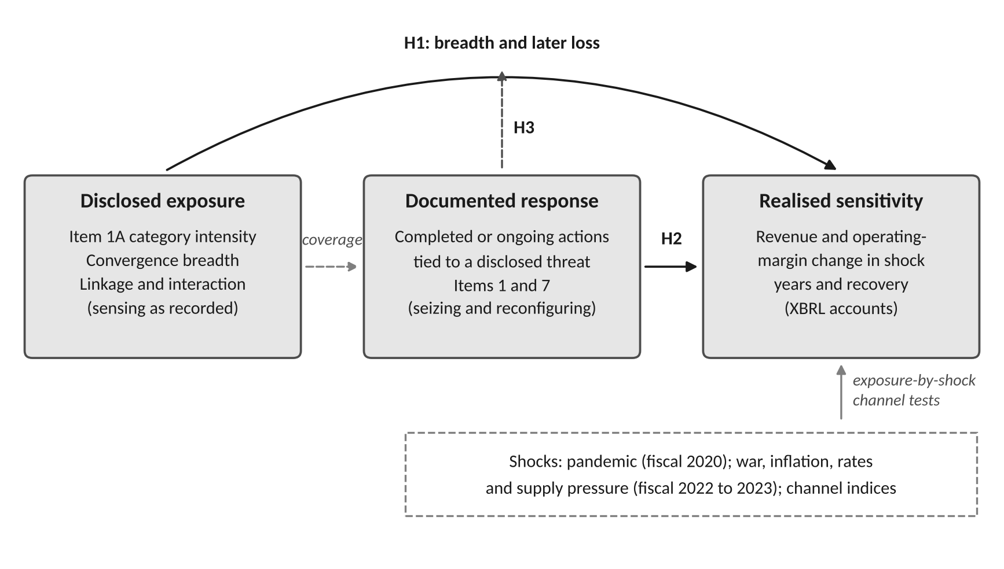
Source: author's design.

Data and method
The sampling frame started from the 5,720 entities that reported a 2018 public float in SEC XBRL data. Of these, 2,277 reported a float of at least 0.5 billion US dollars. Excluding finance and real estate together with utilities and unclassified entities and requiring a 10-K for fiscal 2018 left 1,597 eligible firms. A proportional stratified random sample of 800 was drawn by SIC division with a fixed seed. Before estimation 13 sampled firms were removed because their reported public float was implausible for their size, because they report in Canadian dollars or because they are blank-check companies, leaving 787 firms. Firms were not required to survive to 2025, so the panel is unbalanced and keeps firms that were acquired or delisted. Table 1 lists the data sources and Table 2 the sample.
Table 1. Data sources, content and coverage
Source | Content used | Coverage | Role in the study
SEC EDGAR submissions and 10-K filings | Items 1, 1A and 7 of the latest original 10-K for each fiscal year | 787 firms; 6,214 filings; fiscal 2017 to 2025 | Disclosed exposure, convergence, documented response
SEC XBRL company facts | 2,240,714 fact rows; first-reported annual values | Fiscal 2013 to 2026 | Revenue, cost, margins, inventory, controls
SEC XBRL frames (public float) | Entity public float reported for 2018 | 5,720 entities | Sampling frame
Geopolitical Risk index (Caldara and Iacoviello) | Monthly global index | 1985 to September 2026 | Geopolitical shock
Economic Policy Uncertainty (Baker, Bloom and Davis) | US index with trade policy and regulation components | 1985 to September 2026 | Policy, trade and regulatory shocks
Global Supply Chain Pressure Index (Federal Reserve Bank of New York) | Monthly standardised index | 1998 to September 2026 | Supply-chain shock
World Uncertainty Index (Ahir, Bloom and Furceri) | Quarterly global and US indices | 1952 to 2026 third quarter | Supplementary uncertainty measure
US Bureau of Labor Statistics price indices | CPI-U all items (seasonally adjusted); PPI final demand | January 2012 to September 2026 | Deflating revenue; inflation context
Note: Indices were averaged over the twelve months ending in each firm's fiscal year-end month in the primary models. A second download of all 8 macro files on 25 October 2026 returned byte-identical files. The October 2025 CPI value is missing in the BLS file and was interpolated. Retrieval dates and checksums are held in the project repository. Source: author's compilation.
Filings were retrieved from the SEC EDGAR submissions interface under its fair-access rules. For each firm and fiscal year from 2017 to 2025 the latest original 10-K was converted to text and Items 1, 1A and 7 were located by heading patterns; Item 1A was extracted from 99.8 per cent and the management discussion from 98.4 per cent of the 6,214 filings. Financial data come from 2,240,714 XBRL fact rows, using values as first reported so that later restatements cannot leak into the analysis. The Geopolitical Risk index, the US economic and trade policy uncertainty indices, the World Uncertainty Index and the Global Supply Chain Pressure Index were downloaded from their publishers (Caldara and Iacoviello, 2022; Baker et al., 2016; Ahir et al., 2022; Benigno et al., 2022); a second download on 25 October 2026 returned byte-identical files for all 8 series. Consumer and producer price indices came from the Bureau of Labor Statistics. To confirm the evidence base the full pipeline was rerun from the raw filings and financial facts at the commit of the first version: 3,071 of 3,071 reported quantities were reproduced exactly; a separate re-implementation of the sample draw, panel construction and principal regressions, written without the analysis code, matched all 110 values it checked.
Each Item 1A sentence was assigned to any of nine categories using a dictionary of phrase patterns. The categories are geopolitical conflict, trade policy, regulatory change, cybersecurity, artificial intelligence and technology, supply chain, climate and environment, macro-financial instability and pandemic. A transparent dictionary was preferred to a trained classifier because its errors can be inspected sentence by sentence (Loughran and McDonald, 2011; Loughran and McDonald, 2016; Gentzkow et al., 2019). Across fiscal years mean geopolitical intensity tracked the Geopolitical Risk index (r = 0.86), trade intensity tracked trade policy uncertainty (r = 0.83) and regulatory intensity tracked regulatory policy uncertainty (r = 0.76), whereas supply-chain intensity did not fall back when supply pressure eased (r = 0.19). Geopolitical, trade and macro-financial intensity rose with the foreign share of pre-tax income (Spearman correlations of 0.19 to 0.25, n = 518). An audit of classified sentences found low precision for some patterns. After one revision of the dictionary, pooled category precision on a fresh sample rose from 0.86 to 0.94 (Table A1). A category is material for a firm-year when it accounts for at least three sentences. Convergence breadth counts material categories from zero to nine. Because breadth may reflect disclosure conventions it was compared with twelve alternatives (Table A3). Four change the count: one- and five-sentence thresholds, breadth counted only from sentences free of boilerplate (sentences without four-word sequences shared by 30 to 75 per cent of that year's filings, after Lang and Stice-Lawrence, 2015) and industry-adjusted breadth. Five describe the mix and links between categories: the total share of category sentences, an entropy-based diversity index, the number of linked category pairs, the share of sentences linking categories and the share stating that one category causes or worsens another. Three describe change and repetition: the turnover of material categories from the previous year, the number of newly material categories and the share of Item 1A text in boilerplate sentences.
Documented response was measured from Items 1 and 7 under four rules. The original and revised rules of the first version flag a sentence when an organisational subject, a realised action verb and a category term occur together without conditional wording. High-confidence rules add the conditions of a written coding manual: an explicit link between the action and the threat, no future or aspirational wording, no standing treasury instruments and no descriptions of products sold to customers. The fourth rule is a zero-shot natural language inference model (MoritzLaurer/DeBERTa-v3-base-mnli-fever-anli) that scores whether a sentence states that the company has already acted to reduce or manage its exposure to the category (Yin et al., 2019; Laurer et al., 2024), applied with a fixed threshold of 0.5 to candidate sentences. The coding manual separates risk recognition, disclosure, anticipation, routine activity, reactive management, proactive adaptation and resource reconfiguration and counts a pair as a documented response only when the action is reactive or proactive, completed or ongoing and tied to the threat. A stratified sample of 282 sentence-category pairs drawn across rule strata and categories, 7 industry divisions and 9 fiscal years was coded against the manual. Design weights give population precision, recall and F1 with bootstrap intervals (Wilson, 1927). The reference labels were assigned by an AI assistant applying the manual. They are not independent human annotation. The coding sheets, manual and agreement code (Cohen, 1960; Hayes and Krippendorff, 2007) are released for two human coders.
The hypotheses were tested in two shock episodes. In the pandemic episode severity is the log change in revenue from fiscal 2019 to fiscal 2020, margin change is the change in operating margin over the same years and recovery is the log ratio of fiscal 2022 to fiscal 2019 revenue; predictors come from the fiscal 2018 10-K, filed before the pandemic by every firm. In the 2022 episode outcomes compare fiscal 2022 and 2023 with fiscal 2021 and predictors come from the fiscal 2020 10-K. A placebo episode uses fiscal 2017 predictors and the fiscal 2018 to 2019 change, a period without a systemic shock. The models are ordinary least squares with two-digit SIC and fiscal year-end month fixed effects, controlling for the nine category intensities and for log assets, liabilities to assets, cash to assets, return on assets, prior two-year revenue growth and log Item 1A length. Errors are clustered by two-digit SIC. Because the 53 clusters are uneven (the largest holds 16.1 per cent of firms and the effective number is about 14), the principal tests also report t(52) reference p-values and restricted wild cluster bootstrap p-values from 4,999 draws (Cameron et al., 2008; MacKinnon and Webb, 2017; MacKinnon et al., 2023). The three pre-registered confirmatory tests on pandemic severity are adjusted with the Holm procedure and the exploratory tests with the Benjamini-Hochberg false discovery rate (Holm, 1979; Benjamini and Hochberg, 1995). Null results are read through confidence intervals and equivalence tests (Lakens, 2017).
A firm-year panel for fiscal 2019 to 2025 adds firm and year fixed effects with lagged predictors. Macro indices are common to all firms in a year, so their direct effects are absorbed by year effects; they enter only as interactions with each firm's fiscal 2018 category intensity, in the spirit of exposure-by-shift designs (Goldsmith-Pinkham et al., 2020; Borusyak et al., 2022). The shock models were re-estimated with indices measured at the fiscal year-end month, at their peak within the fiscal year and as year-on-year changes, with industry-by-year fixed effects and with errors clustered by industry. Revenue was deflated by the consumer price index. Cost of revenue, gross margin and inventory were added as outcomes to examine how revenue changes arose. None of these models identifies causal effects of disclosure. They test whether disclosed convergence and documented response carry information about subsequent performance.

Results
Emerging risk disclosure converged steadily over the nine years (Figures 2 and 3). Mean breadth rose from 5.06 categories in fiscal 2017 to 7.83 in fiscal 2025 and the share of firms with all nine categories material rose from 0.5 per cent to 35.3 per cent. Geopolitical risk was material for 54.6 per cent of firms in fiscal 2017 and 87.6 per cent in fiscal 2025; trade policy rose from 30.2 per cent to 85.0 per cent. Dispersion across firms fell as the mean rose. The coefficient of variation of breadth fell from 0.315 to 0.162 and the decline appears under counts that are far from their ceiling: from 0.434 to 0.246 with a five-sentence threshold, from 0.465 to 0.295 when only sentences free of shared boilerplate are counted and from 0.287 to 0.173 among the 622 firms that never reached nine categories. Over the same years the share of Item 1A text in boilerplate sentences rose from 47.3 per cent to 54.5 per cent, while sentences linking two categories rose only from 1.09 per cent to 3.13 per cent of risk sentences. Breadth rose in every SIC division with at least 15 sampled firms (Figure 4).
Figure 2. Share of firms with each emerging risk category material in Item 1A, fiscal 2017 to 2025
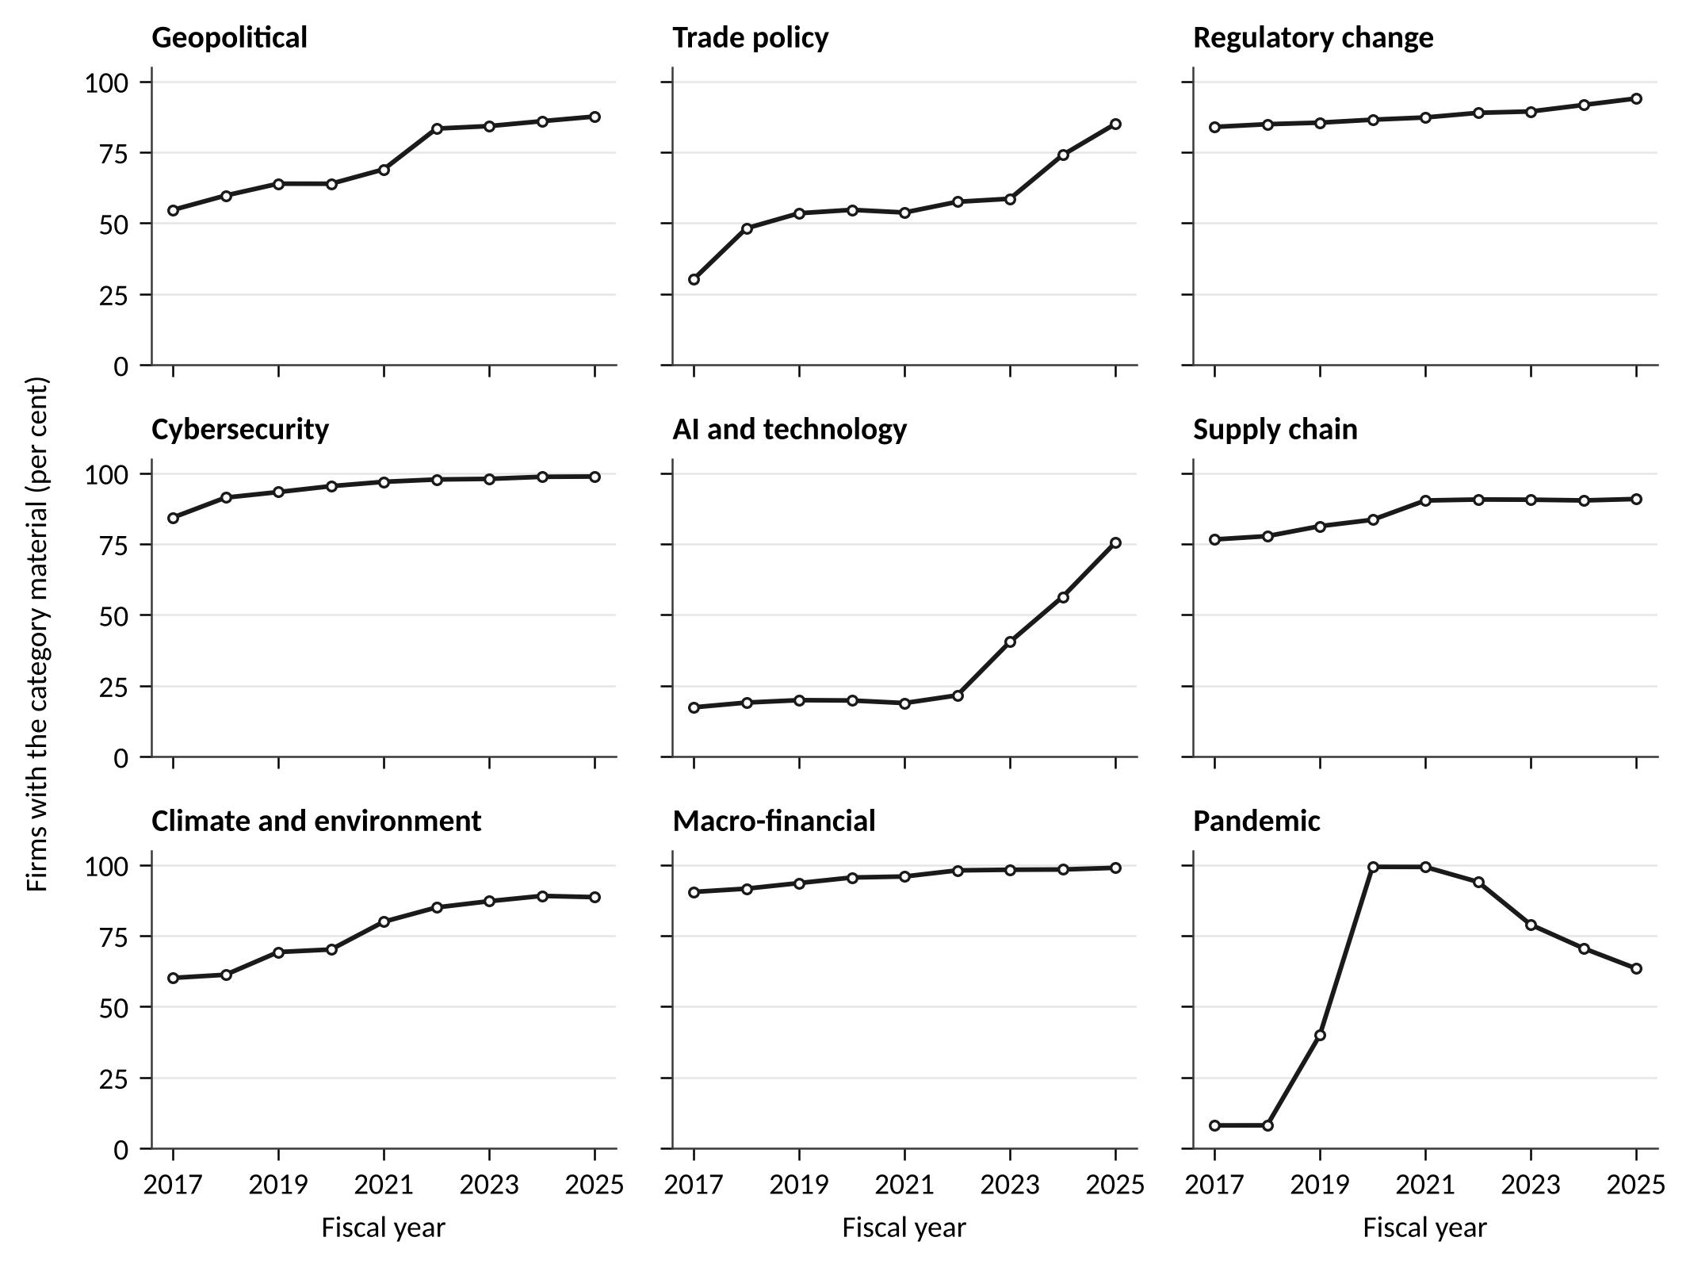
Note: Material means at least three Item 1A sentences in the category. Source: SEC EDGAR 10-K filings of 787 sampled US non-financial firms; author's analysis.
Figure 3. Convergence breadth and dispersion across firms under alternative counts, fiscal 2017 to 2025
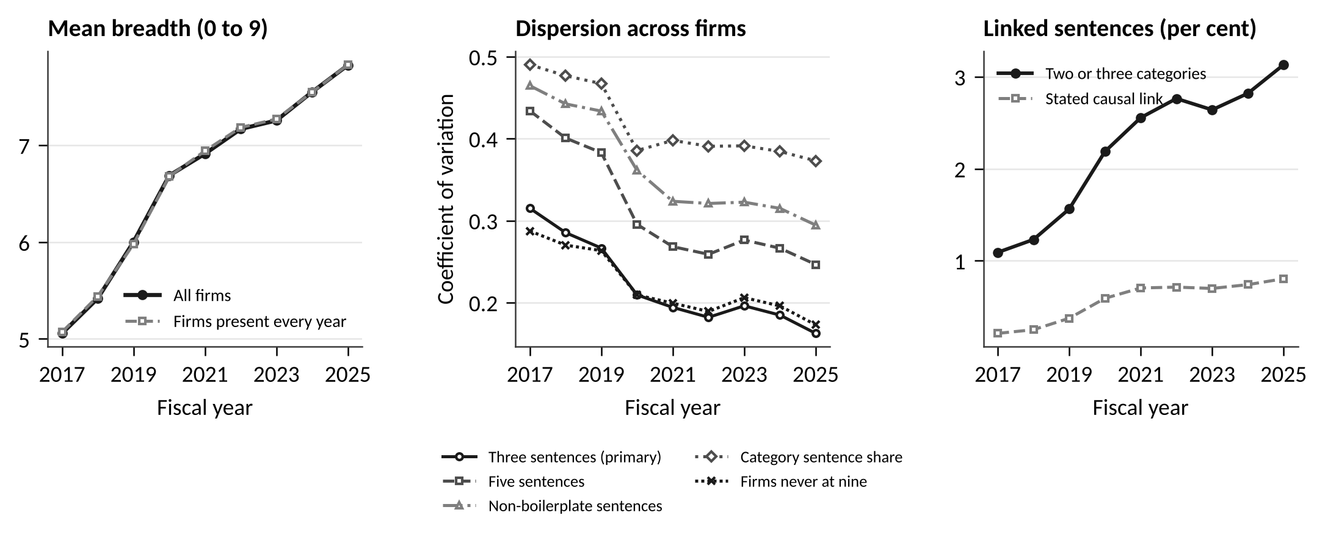
Note: Dispersion is the coefficient of variation across firms. Source: SEC EDGAR 10-K filings; author's analysis.
Breadth reflects reporting practice as much as exposure. Item 1A length alone explained 13.1 per cent of the variance in breadth in fiscal 2018 and 22.8 per cent in fiscal 2025, whereas firm size explained at most 0.3 per cent in the three years tested. Length, size and foreign income share together explained 15.9 per cent in fiscal 2018 and 25.6 per cent in fiscal 2025; adding two-digit industry raised the figures to 37.8 per cent and 44.2 per cent. More than half the variation in breadth is therefore unrelated to observable size, international exposure, industry or document length.
Figure 4. Mean convergence breadth by SIC division, fiscal 2017 to 2025
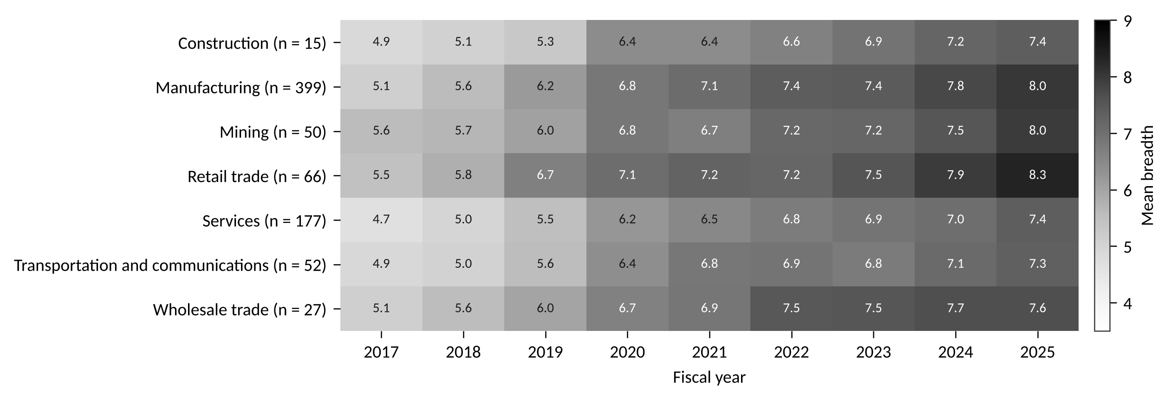
Note: Divisions with at least 15 sampled firms; n = firms in fiscal 2018. Source: SEC EDGAR 10-K filings; author's analysis.
The validation of the response measures changed what the first version could claim (Table 3). Of 302,719 sentence-category pairs in the management discussion and business description of the sampled firms, 12,956 were candidates flagged by a rule or close to one. Of the 282 audited pairs, 91 recorded no organisational action, 89 described routine activity, 9 stated plans, 58 described reactive risk management and 35 proactive adaptation; 88 met every condition for a documented response. The original rules reached a weighted precision of 0.21 and the revised rules 0.23, so roughly three of every four sentences they counted were not responses to the threat. The main errors were sentences with no organisational action, categories that were not relevant to the sentence, products sold to customers and standing treasury instruments. The high-confidence rules reached a precision of 0.87 with recall of 0.28; the language model reached precision of 0.49 with recall of 0.86 and the highest F1 (0.62). Recall is measured within the candidate pairs. None of the 27 audited pairs outside the candidates qualified, but with a Wilson upper bound of 12.5 per cent the audit cannot rule out documented responses that no rule detects.
Table 3. Validation of four documented-response measures against the coding manual
Rule | Flagged in sample | Of which qualify | Precision, sample [Wilson 95%] | Precision, weighted [95%] | Recall, weighted [95%] | F1, weighted [95%] | Population pairs flagged
Original rules | 195 | 75 | 0.38 [0.32, 0.45] | 0.21 [0.15, 0.29] | 0.60 [0.43, 0.86] | 0.32 [0.23, 0.41] | 7,209
Revised rules | 148 | 67 | 0.45 [0.37, 0.53] | 0.23 [0.17, 0.32] | 0.49 [0.34, 0.72] | 0.31 [0.23, 0.41] | 5,406
High-confidence rules | 67 | 48 | 0.72 [0.60, 0.81] | 0.87 [0.81, 0.93] | 0.28 [0.21, 0.44] | 0.43 [0.33, 0.59] | 834
Language model on candidates | 115 | 80 | 0.70 [0.61, 0.77] | 0.49 [0.34, 0.64] | 0.86 [0.73, 0.97] | 0.62 [0.47, 0.74] | 4,484
Revised rules confirmed by language model | 82 | 62 | 0.76 [0.65, 0.84] | 0.47 [0.32, 0.68] | 0.46 [0.31, 0.68] | 0.46 [0.33, 0.63] | 2,479
Note: 282 sentence-category pairs drawn by stratified random sampling across rule strata, nine categories, 7 SIC divisions and 9 fiscal years; 88 qualify. Weighted figures apply design weights and give population estimates; intervals for weighted figures come from 2,000 stratified bootstrap draws. Recall is estimated within candidate pairs. Reference labels were assigned by an AI assistant applying the written coding manual and are not independent human annotation; the blank sheets for two human coders are released with the data. Source: author's analysis.
Measured strictly, documented response was rare before the pandemic. In fiscal 2018 30.9 per cent of firms reported at least one response under the revised rules but only 2.4 per cent under the high-confidence rules and 22.2 per cent under the language model. By fiscal 2020 the high-confidence share had risen to 29.7 per cent, almost entirely through pandemic responses; it stood at 7.4 per cent in fiscal 2025. The response variable used in H2 and H3 therefore has little variation in the pandemic test: 97.3 per cent of firms have zero high-confidence coverage in fiscal 2018.
H1 is not supported (Table 4 and Figure 5). In the pandemic episode a one standard deviation increase in fiscal 2018 breadth was associated with a change in fiscal 2020 revenue of b = −0.004, 95 per cent CI [−0.032, 0.024], p = 0.765; the wild bootstrap p-value is 0.774 and the Holm-adjusted p-value 0.987. The interval rules out a fall in revenue of more than 3.3 per cent per standard deviation, which is small beside the standard deviation of the outcome (0.317 log points). Breadth was also unrelated to the change in operating margin (b = −0.008, p = 0.710). None of the 12 alternative convergence measures predicted the pandemic revenue fall; the smallest p-value among them was 0.132. Breadth did not predict which firms were still filing in fiscal 2022 (logit p = 0.778); the estimate barely moved when the sample was limited to survivors or reweighted for attrition (b = −0.003, p = 0.859; b = −0.007, p = 0.623). In the placebo period from fiscal 2018 to 2019 breadth was not associated with revenue change at conventional levels (b = −0.022, p = 0.094).
The 2022 episode gives the same answer. Breadth in fiscal 2020 was unrelated to the change in operating margin in fiscal 2022 (b = −0.011, p = 0.268) and to revenue growth from fiscal 2021 to 2023 (b = 0.017, p = 0.454). The association with the fiscal 2023 margin change (b = −0.095, 95 per cent CI [−0.188, −0.002], p = 0.040) is the only H1 estimate in this episode with a conventional p-value below 0.05. It does not survive the wild bootstrap (p = 0.105) or the false discovery rate adjustment (q = 0.17). It reappears with the five-sentence threshold (b = −0.076, p = 0.020) but not with the one-sentence threshold (b = 0.017, p = 0.523) or the non-boilerplate count (b = 0.002, p = 0.962) (Table A3). It is reported as unconfirmed.
Table 4. Hypothesis tests under four response measures in two shock episodes
Test and measure | Revenue fall FY2020 | Margin change FY2020 | Recovery FY2022 | Margin change FY2022 | Margin change FY2023 | Revenue FY2021 to FY2023
H1. Convergence breadth (primary)
Breadth, b (p) | −0.004 (0.765) | −0.008 (0.710) | 0.056 (0.006) | −0.011 (0.268) | −0.095 (0.040) | 0.017 (0.454)
Wild bootstrap p | 0.774 |  | 0.027 |  | 0.105
Holm p or BH q | 0.987 | q 0.918 | q 0.063 | q 0.726 | q 0.175 | q 0.855
H2. Response coverage, b (p)
Original rules | 0.004 (0.722) | −0.026 (0.483) | 0.013 (0.262) | −0.002 (0.831) | −0.009 (0.732) | 0.007 (0.585)
Revised rules (primary) | 0.007 (0.493) | 0.004 (0.832) | 0.008 (0.499) | 0.001 (0.932) | 0.013 (0.525) | 0.009 (0.464)
High-confidence rules | 0.000 (0.970) | 0.005 (0.852) | −0.003 (0.624) | 0.001 (0.806) | −0.065 (0.234) | 0.017 (0.072)
Language model | −0.014 (0.064) | −0.028 (0.332) | −0.021 (0.136) | −0.002 (0.818) | −0.016 (0.292) | 0.006 (0.559)
H3. Breadth x coverage, b (p)
Original rules | −0.012 (0.160) | −0.014 (0.245) | −0.036 (0.006) | 0.006 (0.552) | 0.030 (0.275) | 0.006 (0.573)
Revised rules (primary) | −0.022 (0.007) | −0.022 (0.075) | −0.035 (<0.001) | 0.001 (0.860) | 0.003 (0.837) | 0.000 (0.980)
High-confidence rules | −0.024 (0.062) | 0.003 (0.791) | −0.020 (0.173) | −0.008 (0.323) | 0.015 (0.398) | 0.002 (0.888)
Language model | −0.004 (0.786) | 0.021 (0.521) | −0.028 (0.286) | 0.004 (0.632) | −0.009 (0.645) | −0.007 (0.435)
Revised rules: wild bootstrap p; Holm p | 0.007; 0.020
Firms (H1) | 678 | 638 | 627 | 598 | 576 | 611
Note: Coefficients per standard deviation of the predictor; p-values from errors clustered by two-digit SIC with a t(52) reference. Wild bootstrap: restricted wild cluster bootstrap, Rademacher weights, 4,999 draws. Holm adjustment across the three confirmatory tests on pandemic revenue severity; BH q is the Benjamini-Hochberg adjustment across exploratory tests. Predictors from fiscal 2018 (pandemic) and fiscal 2020 (2022 episode). All models include the nine category intensities, log assets, leverage, cash to assets, return on assets, prior two-year revenue growth, log Item 1A words and two-digit SIC and fiscal year-end month fixed effects. n.e.: not estimated because fewer than ten firms had a non-zero value. Source: author's analysis.
Figure 5. Hypothesis tests with 95 per cent confidence intervals under four response measures
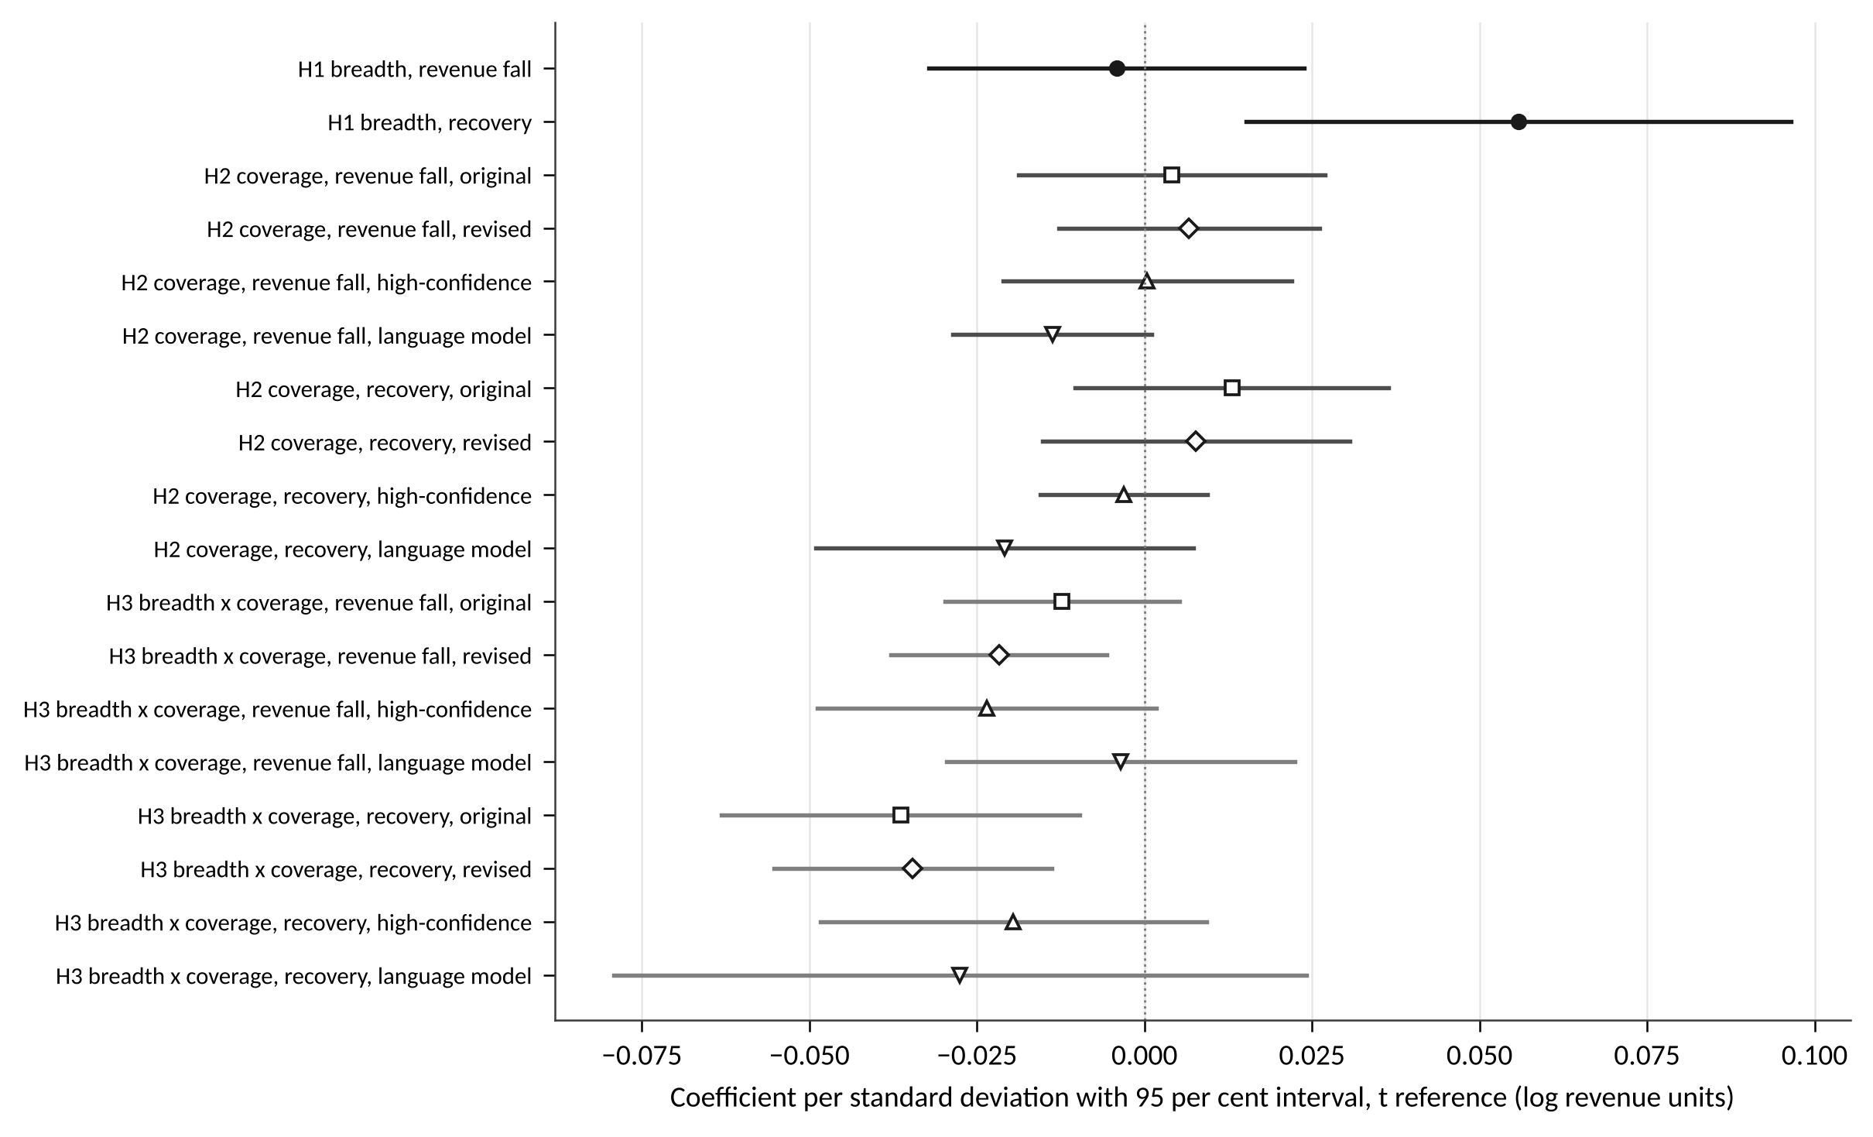
Note: Cross-sectional OLS with two-digit SIC and fiscal year-end month fixed effects, category intensities and controls; errors clustered by two-digit SIC; t(52) intervals. Source: author's analysis.
One exploratory association runs against the polycrisis argument. Firms with greater fiscal 2018 breadth recovered more revenue by fiscal 2022 (b = 0.056, 95 per cent CI [0.015, 0.097], p = 0.006; wild bootstrap p = 0.027; q = 0.063). Table 5 shows why it should not be read as evidence that wider disclosure aids recovery. With three-digit industry fixed effects the estimate falls to 0.047 (p = 0.126) and with all alternative explanations entered together (peer recovery, peer pandemic severity, geographic and acquisition-based diversification, business scope, reporting length, market position, strategic flexibility and prior pandemic disclosure) it falls to 0.040 (p = 0.066; wild bootstrap p = 0.119). When each category enters separately only supply-chain materiality is associated with recovery (b = 0.099, p = 0.022). Among the alternative measures only industry-adjusted breadth (b = 0.051, p = 0.006) and the number of newly material categories (b = 0.027, p = 0.003) carry a similar association; breadth counted from non-boilerplate sentences does not (b = 0.028, p = 0.138). The association is better explained by finer industry composition and supply-chain exposure than by the number of risks disclosed.
Table 5. Scrutiny of the recovery association and the breadth-by-coverage interaction, pandemic episode
Specification | b | p | Firms
Panel A. Breadth and pandemic recovery
Primary specification | 0.056 | 0.006 | 627
Three-digit SIC fixed effects | 0.047 | 0.126 | 627
Peer recovery (industry leave-one-out mean) | 0.054 | 0.004 | 624
Pandemic demand shock (peer severity) | 0.050 | 0.009 | 624
Foreign income share (geographic diversification) | 0.055 | 0.031 | 420
Revenue size and share of industry revenue (market position) | 0.071 | 0.006 | 627
R&D intensity, capex rate and inventory (strategic flexibility) | 0.062 | 0.007 | 627
Pandemic category material in FY2018 | 0.048 | 0.018 | 627
All of the above jointly | 0.040 | 0.066 | 419
Supply-chain category material (category indicators in place of breadth) | 0.099 | 0.022 | 627
Panel B. Breadth x revised-rule coverage | Revenue fall | Recovery | Firms
Primary specification | −0.022 (0.007) | −0.035 (<0.001) | 678
Firms with any revised-rule response only | 0.002 (0.921) | −0.012 (0.650) | 215
Excluding distressed firms (negative ROA or top-quintile leverage) | −0.023 (0.004) | −0.038 (<0.001) | 407
Manufacturing only | −0.018 (0.022) | −0.052 (<0.001) | 348
Excluding manufacturing | −0.022 (0.262) | 0.001 (0.928) | 330
Control for peer severity | −0.016 (0.018) | −0.032 (0.002) | 675
FY2019 text filed before 1 March 2020 | −0.016 (0.100) | −0.003 (0.792) | 517
Note: Panel A: coefficient on breadth (per standard deviation) for revenue recovery from fiscal 2019 to 2022, adding each alternative explanation in turn to the primary model. Panel B: interaction coefficient with p-values in brackets. Errors clustered by two-digit SIC. Source: author's analysis.
H2 is not supported under any response measure. Coverage measured in fiscal 2018 was unrelated to the pandemic revenue fall (original rules b = 0.004, p = 0.722; revised rules b = 0.007, p = 0.493; high-confidence rules b = 0.0004, p = 0.970; language model b = −0.014, p = 0.064) and to recovery (original rules b = 0.013, p = 0.262; revised rules b = 0.008, p = 0.499; high-confidence rules b = −0.003, p = 0.624; language model b = −0.021, p = 0.136). None of the 24 H2 estimates across measures, outcomes and the two episodes had a p-value below 0.05. The one coverage measure that requires a stated resource commitment had non-zero values for too few firms in fiscal 2018 to be estimated in the pandemic episode; in the 2022 episode it was associated with higher revenue growth from fiscal 2021 to 2023 (b = 0.030, p = 0.007, q = 0.17). Within categories, firms that documented a high-confidence pandemic response by fiscal 2020 had higher revenue growth from fiscal 2021 to 2023 than other firms for which pandemic risk was material, but the estimate is imprecise (b = 0.054, p = 0.052).
H3 predicted that coverage would weaken the association between breadth and loss. The confirmatory estimate has the opposite sign: among firms with higher revised-rule coverage, breadth was associated with a larger pandemic revenue fall (b = −0.022, 95 per cent CI [−0.038, −0.006], p = 0.007; wild bootstrap p = 0.007; Holm-adjusted p = 0.020); the same pattern appears for recovery (b = −0.035, p < 0.001; q = 0.026). The marginal effects show where the interaction comes from. At zero coverage, which describes 71.0 per cent of firms, breadth was unrelated to the revenue fall and positively associated with recovery (b = 0.071, p = 0.001). The negative association appears only at a coverage of one quarter or more (−0.046 at 0.25), a level that 5.6 per cent of firms exceeded.
Table 5 asks whether the interaction reflects response at all. Among the firms with any revised-rule response it vanished for both the revenue fall (b = 0.002, p = 0.921) and recovery (b = −0.012, p = 0.650). The recovery interaction was confined to manufacturing (b = 0.001, p = 0.928 outside it), while the severity interaction outside manufacturing had a similar size but was imprecise (b = −0.022, p = 0.262). With predictors taken from fiscal 2019 reports filed before 1 March 2020 the recovery interaction fell to −0.003 (p = 0.79) and the severity interaction to −0.016 (p = 0.10). In the placebo period without a systemic shock the interaction was small (b = −0.006, p = 0.241). It persisted when distressed firms were excluded (b = −0.038, p < 0.001 for recovery) and when peer severity was controlled (b = −0.016, p = 0.018 for severity). The more accurate measures point the same way with less precision. The high-confidence severity interaction was −0.024 (p = 0.062) and the recovery interaction −0.020 (p = 0.173); under the language model they were −0.004 (p = 0.786) and −0.028 (p = 0.286). For the 16 firms with any high-confidence response in fiscal 2018 the interaction with breadth was −0.156 for severity (p = 0.004) and −0.159 for recovery (p = 0.037).
No measure shows documented response weakening the link between breadth and loss. The opposite pattern is fragile because it rests on few firms, disappears within responders and changes with the reporting year. A plausible explanation that the data cannot test is that firms documenting responses before the pandemic were those whose threats had already materialised. A documented response would then mark realised exposure more than protection.
The firm-year panel shows where realised sensitivity came from (Table 6). In years of high geopolitical risk, firms with greater fiscal 2018 geopolitical intensity had higher nominal revenue growth (b = 0.015, p < 0.001 per standard deviation of both exposure and index) and higher cost-of-revenue growth (b = 0.016, p < 0.001), with no change in gross margin (b = −0.0004, p = 0.591). Supply-chain exposure in years of high supply-chain pressure shows the same pattern for revenue (b = 0.014, p = 0.001) and cost (b = 0.011, p = 0.006), with faster inventory growth (b = 0.026, p < 0.001). These high-index years were also years of high inflation. The pattern is consistent with exposed firms passing higher input costs into prices. The data contain no firm-level prices, so pass-through is a plausible explanation that the study does not test. Deflating revenue by the consumer price index cannot separate price from volume because a common deflator is absorbed by the year effects (b = 0.014, p < 0.001 for real growth).
Macro-financial exposure is the only channel associated with lower performance. In years of high US policy uncertainty, firms with greater macro-financial intensity had lower revenue growth (b = −0.010, p = 0.009) and lower operating-margin change (b = −0.022, p = 0.027). The association remained with industry-by-year fixed effects (b = −0.008, p = 0.017) but not with errors clustered by industry (b = −0.010, p = 0.123 for revenue; b = −0.022, p = 0.157 for margin). The geopolitical association lost conventional significance under two-way clustering (b = 0.015, p = 0.112) and the supply-chain association under industry clustering (b = 0.014, p = 0.078). Combined exposure added nothing measurable. The interaction between breadth and the number of indices at high levels was 0.002 for revenue growth, with a 95 per cent interval of [−0.003, 0.006] that excludes the smallest single-channel effect in the model (0.010; equivalence test p < 0.001); for operating margin the interval was [−0.010, 0.010] against a bound of 0.022 (p < 0.001).
Table 6. Pre-shock exposure and realised sensitivity by channel, fiscal 2019 to 2025
Interaction | Revenue growth | Revenue growth, industry clusters | Revenue growth, industry-by-year effects | Cost of revenue growth | Gross margin change | Operating margin change
Geopolitical exposure x GPR | 0.0146** | 0.0146** | 0.0094** | 0.0158** | −0.0004 | 0.0048
Supply-chain exposure x GSCPI | 0.0140** | 0.0140 | 0.0178** | 0.0114** | 0.0009 | −0.0000
Trade exposure x trade policy uncertainty | 0.0024 | 0.0024 | −0.0030 | 0.0027 | 0.0003 | 0.0017
Regulatory exposure x regulation uncertainty | 0.0003 | 0.0003 | 0.0018 | −0.0048 | −0.0002 | 0.0051
Macro-financial exposure x EPU | −0.0098** | −0.0098 | −0.0082* | −0.0023 | −0.0010 | −0.0217*
Pandemic exposure x fiscal 2020 | −0.0188 | −0.0188 | −0.0108 | −0.0086 | −0.0028 | −0.0190
Breadth x number of high indices | 0.0018 | 0.0018 | 0.0004 | 0.0048 | 0.0001 | 0.0000
Firm-years | 4,567 | 4,567 | 4,567 | 3,324 | 3,477 | 4,300
Note: Exposure is the fiscal 2018 category intensity, standardised; each index is the fiscal-year average, standardised. Firm and year fixed effects unless stated; errors clustered by firm unless stated; * p < 0.05, ** p < 0.01. Lagged convergence, coverage and controls included. Alternative index timings (year-end month, within-year peak, year-on-year change) and two-way clustering are reported in the workbook. Source: author's analysis.
Table 7 sets the statistical results beside eight large firms chosen by rule from the pandemic episode. Firms with similar breadth fared very differently. Ford Motor disclosed 5 material categories and lost 18.5 per cent of revenue in fiscal 2020; General Motors disclosed 7 and lost 10.8 per cent. Every action that the first version counted as a documented response for these firms was routine under the coding manual. Marathon Petroleum's counted actions were the transfer of logistics assets to its affiliate and lower crude acquisition costs; Caterpillar's included its standing currency hedging programme; neither firm had a high-confidence response in fiscal 2018. Marathon Petroleum lost 43.7 per cent of revenue and Caterpillar 22.4 per cent. The cases illustrate the two central findings: the number of disclosed risks did not separate firms facing the same shock and the activity that rules record as response was largely the ordinary conduct of the business.
Table 7. Illustrative cases from the pandemic episode
Firm | Breadth group | Material categories, FY2018 | Actions counted, revised rules | Coding-manual verdict | High-confidence actions | Revenue FY2019 to FY2020 | Revenue FY2022 vs FY2019
Ford Motor | at or below median | Geo, Trade, Cyber, Supply, Macro | None | No action counted | None | −18.5% | 1.4%
Amazon.com | at or below median | Geo, Cyber, Supply, Climate, Macro | None | No action counted | None | 37.6% | 83.3%
Marathon Petroleum | at or below median | Geo, Reg, Cyber, Supply, Climate, Macro | Supply | Routine (asset transfer to affiliate; logistics) | None | −43.7% | 43.2%
United Parcel Service | at or below median | Geo, Reg, Cyber, Climate, Macro | Supply | Routine (acquisitions) | None | 14.2% | 35.4%
General Motors | above median | Geo, Trade, Reg, Cyber, Supply, Climate, Macro | None | No action counted | None | −10.8% | 14.2%
Walmart | above median | Geo, Trade, Reg, Cyber, Supply, Climate, Macro | None | No action counted | None | 6.7% | 16.6%
Caterpillar | above median | Geo, Trade, Reg, Cyber, Supply, Climate, Macro | Supply, Macro | Routine (standing currency hedging) | None | −22.4% | 10.4%
McKesson | above median | Trade, Reg, Cyber, Supply, Climate, Macro, Pandemic | Supply | Routine (outsourcing for efficiency) | None | 3.1% | 19.7%
Note: Within each breadth group the rule selects the largest firm by fiscal 2019 revenue whose revenue fell by more than ten per cent and the largest whose revenue did not fall, with and without a counted action. The verdict applies the coding manual to the sentences the revised rules counted. Source: SEC EDGAR 10-K filings and XBRL company facts; author's analysis.

Discussion
The study set out to test two assumptions behind current risk practice. The first, that firms disclosing more converging risks are more fragile, finds no support in either shock. The evidence is consistent with disclosure saturation. Risk lists grew towards their ceiling and became more alike under every way of counting categories, boilerplate grew faster than firm-specific text and the remaining variation in breadth followed document length and industry more than size or international exposure. Breadth then carried no information about who lost most in either shock; the interval for the pandemic estimate excludes effects of a size that would matter to a board. This extends work on the informativeness of risk factors (Campbell et al., 2014; Hope et al., 2016; Dyer et al., 2017) by showing that the aggregate count loses its information as disclosure saturates while channel-specific intensity keeps it. The panel models show that geopolitical, supply-chain and macro-financial intensity each tracked realised sensitivity in the years when its index was high.
The second assumption, that documented response indicates preparedness, depends on a measurement problem that the validation exposed. Rules that pair an organisational subject, an action verb and a risk term mostly record routine activity: acquisitions, hedging programmes, supply contracts and products sold to customers. Once the coding manual's conditions were applied, responses explicitly tied to a disclosed threat were rare before the pandemic and did not protect performance under any of the four measures. Two readings remain open. Firms may act on threats without writing about the action in the business description or management discussion, so the filings understate response. Statements and practice may also be decoupled in the other direction (Meyer and Rowan, 1977; Westphal and Zajac, 2001; Bromley and Powell, 2012). The data cannot separate these readings; either one implies that annual-report text is a weak basis for measuring seizing and reconfiguring.
Zhang et al. (2026) found that closer coordination between the risks and the response measures that Chinese A-share firms reported from 2014 to 2023 predicted better subsequent performance, through lower financing constraints and greater institutional attention. Three differences may explain why the result does not carry over. Their measure takes the reported responses as given, whereas this study audited the sentences that rules classify as responses and found that most described routine activity. Their outcome is performance in ordinary years, which can reflect how investors read the disclosure, whereas this study asks whether responses absorbed two systemic shocks. The disclosure regimes and markets also differ. The two studies agree that the match between threat and action is the construct of interest; they differ on whether the text of US annual reports measures it.
For dynamic capabilities research the results separate three things that are often treated as one (Teece, 2007; Schilke et al., 2018). Disclosed exposure records sensing, but once disclosure saturates the record says more about reporting incentives than about the firm's attention (Ocasio, 1997; Eggers and Kaplan, 2009). Documented response is meant to record seizing and reconfiguring, but the filings record little of either. Realised sensitivity, estimated channel by channel, carries the information about exposure that the aggregate counts lost. Ambidexterity offers one explanation of why firms with similar disclosure fared differently, since protecting the core while repositioning requires separate structures or leadership attention (O'Reilly and Tushman, 2013; Raisch and Birkinshaw, 2008), but the filings contain no measure of it and the study does not test it. Researchers who build capability measures from annual reports should validate them against coded samples before testing performance effects and should report precision and recall alongside the estimates.

Implications for boards and executive teams
Boards receive risk lists that now look alike across firms. The evidence here suggests that the length of the list says little about how much a firm stands to lose. Table 8 and Figure 6 turn the findings into a four-stage diagnostic for the annual risk review. Identify separates the threats specific to the firm from the boilerplate that peers share; a director can ask which Item 1A paragraphs changed this year and why. Quantify attaches each threat to the channel through which it would reach the accounts. The panel results suggest that geopolitical and supply-chain shocks moved revenue and cost together while macro-financial uncertainty reduced operating margin, so the board needs the revenue, cost and asset share exposed in each channel and an estimate of the firm's ability to pass costs into prices. Scenario work that combines two or three named channels serves this stage better than a register that lists everything (Schoemaker, 2022; Mortlock and Osiyevskyy, 2023; Calandro, 2020).
Respond records completed actions tied to a named threat, with the resources committed and an accountable owner. The validation shows how easily routine activity is mistaken for response, so the register should state which threat each action addresses, what changed and when. Validate compares realised revenue and margin changes in the last shock with the channel estimates and revises the first three stages. A chief risk officer can run the diagnostic within the existing annual cycle using segment data, supplier and contract records and the variance analysis that finance already prepares. The study's own measures suggest a test for the board: if the firm's risk factors would read the same with a competitor's name on them, they record compliance rather than exposure.
Table 8. An executive diagnostic for converging strategic risks
Stage | What the evidence shows | Question for the board | Evidence to request | Owner and timing
Identify | Risk lists rose to 7.83 of nine categories; dispersion fell under every count and more than half of Item 1A text sat in boilerplate sentences from fiscal 2019 | Which of our risk statements would read the same for a competitor? | Item 1A changes against last year; firm-specific risks separated from shared text | General counsel and chief risk officer; annual
Quantify | Geopolitical and supply-chain exposure moved revenue and cost together; macro-financial exposure reduced operating margin; combined exposure added nothing measurable | Through which channel would each risk reach the accounts and how much? | Revenue, cost and asset share exposed per channel; contractual ability to pass costs into prices | Chief financial officer; annual and after each shock
Respond | Rules counting response had precision near 0.23; threat-linked responses were rare and none protected performance | What have we completed for each material risk, with what resources? | Register of completed actions tied to a named threat, with cost, owner and date | Executive owner for each risk; quarterly
Validate | Disclosure did not predict who lost most; realised sensitivity by channel did | Did our exposure behave as estimated in the last shock? | Variance analysis of revenue and margin by channel in the shock year | Audit or risk committee; after each shock
Note: The four stages map to sensing (Identify, Quantify), seizing (Respond) and reconfiguring and learning (Validate). Source: author's design based on the study's findings.
Figure 6. Identify, Quantify, Respond, Validate: an executive diagnostic for converging risks
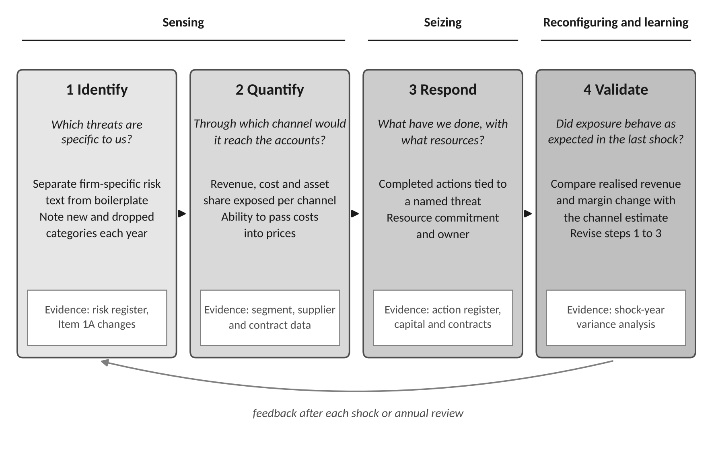
Source: author's design.

Limitations
Several limitations qualify these conclusions. The reference labels for the response validation and the dictionary audit were assigned by an AI assistant applying the written manual. They are not independent human annotation. The precision and recall figures should be treated as provisional until two human coders have coded the released sample and agreement has been reported. Recall is estimated within candidate sentences, so responses phrased in ways no rule detects would be missed. The language model was applied without training on this corpus and its errors may differ by category and year. Disclosure measures what firms choose to report and Item 1A answers legal as well as economic incentives, so disclosed exposure may differ from actual exposure. Outcomes are nominal accounting figures; revenue changes mix price and volume and the pass-through explanation for the channel results is untested.
The sample covers 787 large US non-financial firms, so the results may not hold for smaller firms or for jurisdictions with prescribed response disclosure. Inference rests on 53 industry clusters of uneven size; the wild bootstrap and t references address this, but the macro-financial channel loses statistical significance when errors are clustered by industry. The study tests associations between disclosure and later performance and identifies no causal effect of disclosure or response. The pandemic was a single shock with sector-specific effects and the 2022 episode overlaps with recovery from it.

Conclusion
US firms now disclose almost every emerging risk as material. The number they list no longer identifies which firms lose most when shocks arrive. Measured carefully, responses tied to a disclosed threat were rare in annual reports before the pandemic and none of the response measures protected performance. What remains informative is channel-specific: the intensity of geopolitical, supply-chain and macro-financial exposure tracked realised sensitivity in the years those shocks were strong. Risk practice should therefore move from counting risks to estimating channels and recording completed actions. The most useful next step for research is human double-coding of the released response sample, followed by tests of response measures built from internal action registers rather than public text.

Declarations
Data availability. All data come from public sources: SEC EDGAR filings and XBRL company facts and the published Geopolitical Risk, Economic Policy Uncertainty, World Uncertainty and Global Supply Chain Pressure indices. Collection scripts, retrieval manifests with checksums, the analysis plan with its dated deviations, derived datasets, the response coding manual, validation samples with blank sheets for human coders, a reproduction report and analysis code are available at https://github.com/Imomazin/research-projects (branch revision/strategic-risk, folder Strategy and Strategic Management/Strategy and Leadership/Managing Emerging Strategic Risks; extracted filing text on branch data/strategic-risk).
Use of generative artificial intelligence. Claude (Anthropic) was used to write the data-collection and analysis code, to run the analyses, to draft the manuscript text and to assign the reference labels for the dictionary audit (Table A1) and the response validation sample (Table 3). Those labels are not independent human annotation. A zero-shot natural language inference model was used as one of the four response classifiers. Every reported number is generated by versioned code from the archived data.

References
Ahir, H., Bloom, N. and Furceri, D. (2022), "The World Uncertainty Index", NBER Working Paper No. 29763, doi: 10.3386/w29763.
Andersen, T.J. (2008), "The Performance Relationship of Effective Risk Management: Exploring the Firm-Specific Investment Rationale", Long Range Planning, Vol. 41 No. 2, pp. 155-176, doi: 10.1016/j.lrp.2008.01.002.
Ansoff, H.I. (1975), "Managing Strategic Surprise by Response to Weak Signals", California Management Review, Vol. 18 No. 2, pp. 21-33, doi: 10.2307/41164635.
Bag, S. (2026), "Dynamic Capabilities and Strategic Performance Under Polycrisis: The Roles of Strategic Flexibility and Regenerative Capability", Business Strategy and the Environment, Vol. ahead-of-print No. ahead-of-print, doi: 10.1002/bse.71673.
Baker, S.R., Bloom, N. and Davis, S.J. (2016), "Measuring Economic Policy Uncertainty", The Quarterly Journal of Economics, Vol. 131 No. 4, pp. 1593-1636, doi: 10.1093/qje/qjw024.
Baldwin, R. and Freeman, R. (2022), "Risks and Global Supply Chains: What We Know and What We Need to Know", Annual Review of Economics, Vol. 14 No. 1, pp. 153-180, doi: 10.1146/annurev-economics-051420-113737.
Benigno, G., di Giovanni, J., Groen, J.J. and Noble, A.I. (2022), "The GSCPI: A New Barometer of Global Supply Chain Pressures", SSRN Electronic Journal, Vol. ahead-of-print No. ahead-of-print, doi: 10.2139/ssrn.4114973.
Benjamini, Y. and Hochberg, Y. (1995), "Controlling the False Discovery Rate: A Practical and Powerful Approach to Multiple Testing", Journal of the Royal Statistical Society Series B: Statistical Methodology, Vol. 57 No. 1, pp. 289-300, doi: 10.1111/j.2517-6161.1995.tb02031.x.
Borusyak, K., Hull, P. and Jaravel, X. (2022), "Quasi-Experimental Shift-Share Research Designs", The Review of Economic Studies, Vol. 89 No. 1, pp. 181-213, doi: 10.1093/restud/rdab030.
Bourgeois, L.J. (1981), "On the Measurement of Organizational Slack", The Academy of Management Review, Vol. 6 No. 1, 29, doi: 10.2307/257138.
Bromiley, P., McShane, M., Nair, A. and Rustambekov, E. (2015), "Enterprise Risk Management: Review, Critique, and Research Directions", Long Range Planning, Vol. 48 No. 4, pp. 265-276, doi: 10.1016/j.lrp.2014.07.005.
Bromley, P. and Powell, W.W. (2012), "From Smoke and Mirrors to Walking the Talk: Decoupling in the Contemporary World", Academy of Management Annals, Vol. 6 No. 1, pp. 483-530, doi: 10.5465/19416520.2012.684462.
Bundy, J., Pfarrer, M.D., Short, C.E. and Coombs, W.T. (2017), "Crises and Crisis Management: Integration, Interpretation, and Research Development", Journal of Management, Vol. 43 No. 6, pp. 1661-1692, doi: 10.1177/0149206316680030.
Calandro, J. (2020), "Risk as strategy: defending against catastrophic turns of fortune", Strategy & Leadership, Vol. 48 No. 4, pp. 29-35, doi: 10.1108/sl-04-2020-0061.
Caldara, D. and Iacoviello, M. (2022), "Measuring Geopolitical Risk", American Economic Review, Vol. 112 No. 4, pp. 1194-1225, doi: 10.1257/aer.20191823.
Cameron, A.C., Gelbach, J.B. and Miller, D.L. (2008), "Bootstrap-Based Improvements for Inference with Clustered Errors", Review of Economics and Statistics, Vol. 90 No. 3, pp. 414-427, doi: 10.1162/rest.90.3.414.
Campbell, J.L., Chen, H., Dhaliwal, D.S., Lu, H.M. and Steele, L.B. (2014), "The information content of mandatory risk factor disclosures in corporate filings", Review of Accounting Studies, Vol. 19 No. 1, pp. 396-455, doi: 10.1007/s11142-013-9258-3.
Carvalho, V.M., Nirei, M., Saito, Y.U. and Tahbaz-Salehi, A. (2021), "Supply Chain Disruptions: Evidence from the Great East Japan Earthquake", The Quarterly Journal of Economics, Vol. 136 No. 2, pp. 1255-1321, doi: 10.1093/qje/qjaa044.
Cazier, R.A., Merkley, K.J. and Treu, J.S. (2020), "When are Firms Sued for Qualitative Disclosures? Implications of the Safe Harbor for Forward-Looking Statements", The Accounting Review, Vol. 95 No. 1, pp. 31-55, doi: 10.2308/accr-52443.
Cho, T.S. and Hambrick, D.C. (2006), "Attention as the Mediator Between Top Management Team Characteristics and Strategic Change: The Case of Airline Deregulation", Organization Science, Vol. 17 No. 4, pp. 453-469, doi: 10.1287/orsc.1060.0192.
Cohen, J. (1960), "A Coefficient of Agreement for Nominal Scales", Educational and Psychological Measurement, Vol. 20 No. 1, pp. 37-46, doi: 10.1177/001316446002000104.
Cohen, L., Malloy, C. and Nguyen, Q. (2020), "Lazy Prices", The Journal of Finance, Vol. 75 No. 3, pp. 1371-1415, doi: 10.1111/jofi.12885.
Dai, L., Landsman, W.R. and Peng, Z. (2024), "Private Loan Issuance and Risk Factor Disclosure", The Accounting Review, Vol. 99 No. 4, pp. 169-196, doi: 10.2308/tar-2021-0236.
Day, G.S. and Dennis, R. (2022), "Overcoming the preparedness paradox: five initiatives to ready businesses for an uncertain future disruption", Strategy & Leadership, Vol. 50 No. 5, pp. 9-14, doi: 10.1108/sl-05-2022-0051.
de Waal, G.A., Kenworthy, A.L., Opatska, S., Trevoho, O., Boychuk, Y. and Kozlova, V. (2025), "Exposing Pathways to Organisational Resilience: Revenue Recovery Patterns Among Ukrainian Firms in a War Economy", Journal of Contingencies and Crisis Management, Vol. 33 No. 2, e70058, doi: 10.1111/1468-5973.70058.
DesJardine, M., Bansal, P. and Yang, Y. (2019), "Bouncing Back: Building Resilience Through Social and Environmental Practices in the Context of the 2008 Global Financial Crisis", Journal of Management, Vol. 45 No. 4, pp. 1434-1460, doi: 10.1177/0149206317708854.
Dess, G.G. and Beard, D.W. (1984), "Dimensions of Organizational Task Environments", Administrative Science Quarterly, Vol. 29 No. 1, 52, doi: 10.2307/2393080.
Ding, W., Levine, R., Lin, C. and Xie, W. (2021), "Corporate immunity to the COVID-19 pandemic", Journal of Financial Economics, Vol. 141 No. 2, pp. 802-830, doi: 10.1016/j.jfineco.2021.03.005.
Dyer, T., Lang, M. and Stice-Lawrence, L. (2017), "The evolution of 10-K textual disclosure: Evidence from Latent Dirichlet Allocation", Journal of Accounting and Economics, Vol. 64 No. 2-3, pp. 221-245, doi: 10.1016/j.jacceco.2017.07.002.
Eggers, J.P. and Kaplan, S. (2009), "Cognition and Renewal: Comparing CEO and Organizational Effects on Incumbent Adaptation to Technical Change", Organization Science, Vol. 20 No. 2, pp. 461-477, doi: 10.1287/orsc.1080.0401.
Eisenhardt, K.M. and Martin, J.A. (2000), "Dynamic capabilities: what are they?", Strategic Management Journal, Vol. 21 No. 10-11, pp. 1105-1121, doi: 10.1002/1097-0266(200010/11)21:10/11<1105::aid-smj133>3.0.co;2-e.
Elliott, M., Golub, B. and Leduc, M.V. (2022), "Supply Network Formation and Fragility", American Economic Review, Vol. 112 No. 8, pp. 2701-2747, doi: 10.1257/aer.20210220.
Enang, I. (2026), "Strategy in motion: an auditable decision architecture for strategic recalibration in volatile markets", Strategy & Leadership, Vol. ahead-of-print No. ahead-of-print, doi: 10.1108/sl-05-2026-0211.
Fahlenbrach, R., Rageth, K. and Stulz, R.M. (2021), "How Valuable Is Financial Flexibility when Revenue Stops? Evidence from the COVID-19 Crisis", The Review of Financial Studies, Vol. 34 No. 11, pp. 5474-5521, doi: 10.1093/rfs/hhaa134.
Florackis, C., Louca, C., Michaely, R. and Weber, M. (2022), "Cybersecurity Risk", The Review of Financial Studies, Vol. 36 No. 1, pp. 351-407, doi: 10.1093/rfs/hhac024.
Gentzkow, M., Kelly, B. and Taddy, M. (2019), "Text as Data", Journal of Economic Literature, Vol. 57 No. 3, pp. 535-574, doi: 10.1257/jel.20181020.
Goldsmith-Pinkham, P., Sorkin, I. and Swift, H. (2020), "Bartik Instruments: What, When, Why, and How", American Economic Review, Vol. 110 No. 8, pp. 2586-2624, doi: 10.1257/aer.20181047.
Hassan, T.A., Hollander, S., van Lent, L. and Tahoun, A. (2019), "Firm-Level Political Risk: Measurement and Effects", The Quarterly Journal of Economics, Vol. 134 No. 4, pp. 2135-2202, doi: 10.1093/qje/qjz021.
Hassan, T.A., Hollander, S., van Lent, L., Schwedeler, M. and Tahoun, A. (2023), "Firm-Level Exposure to Epidemic Diseases: COVID-19, SARS, and H1N1", The Review of Financial Studies, Vol. 36 No. 12, pp. 4919-4964, doi: 10.1093/rfs/hhad044.
Hayes, A.F. and Krippendorff, K. (2007), "Answering the Call for a Standard Reliability Measure for Coding Data", Communication Methods and Measures, Vol. 1 No. 1, pp. 77-89, doi: 10.1080/19312450709336664.
Helbing, D. (2013), "Globally networked risks and how to respond", Nature, Vol. 497 No. 7447, pp. 51-59, doi: 10.1038/nature12047.
Helfat, C.E. and Peteraf, M.A. (2015), "Managerial cognitive capabilities and the microfoundations of dynamic capabilities", Strategic Management Journal, Vol. 36 No. 6, pp. 831-850, doi: 10.1002/smj.2247.
Hirshleifer, D. and Teoh, S.H. (2003), "Limited attention, information disclosure, and financial reporting", Journal of Accounting and Economics, Vol. 36 No. 1-3, pp. 337-386, doi: 10.1016/j.jacceco.2003.10.002.
Holm, S. (1979), "A simple sequentially rejective multiple test procedure", Scandinavian Journal of Statistics, Vol. 6, pp. 65-70, doi: 10.2307/4615733.
Hope, O.K., Hu, D. and Lu, H. (2016), "The benefits of specific risk-factor disclosures", Review of Accounting Studies, Vol. 21 No. 4, pp. 1005-1045, doi: 10.1007/s11142-016-9371-1.
Hoyt, R.E. and Liebenberg, A.P. (2011), "The Value of Enterprise Risk Management", Journal of Risk and Insurance, Vol. 78 No. 4, pp. 795-822, doi: 10.1111/j.1539-6975.2011.01413.x.
Huang, Y. (2026), "Same storm, different ships: structural inertia and the paradigm trap in the global auto industry", Strategy & Leadership, Vol. ahead-of-print No. ahead-of-print, doi: 10.1108/sl-04-2026-0183.
Hussain, S.A. (2026), "Selective resource orchestration: rethinking how firms realize value", Strategy & Leadership, Vol. ahead-of-print No. ahead-of-print, doi: 10.1108/sl-01-2026-0011.
Ivanov, D. and Dolgui, A. (2020), "Viability of intertwined supply networks: extending the supply chain resilience angles towards survivability. A position paper motivated by COVID-19 outbreak", International Journal of Production Research, Vol. 58 No. 10, pp. 2904-2915, doi: 10.1080/00207543.2020.1750727.
Kravet, T. and Muslu, V. (2013), "Textual risk disclosures and investors’ risk perceptions", Review of Accounting Studies, Vol. 18 No. 4, pp. 1088-1122, doi: 10.1007/s11142-013-9228-9.
Lakens, D. (2017), "Equivalence Tests: A Practical Primer for t Tests, Correlations, and Meta-Analyses", Social Psychological and Personality Science, Vol. 8 No. 4, pp. 355-362, doi: 10.1177/1948550617697177.
Lang, M. and Stice-Lawrence, L. (2015), "Textual analysis and international financial reporting: Large sample evidence", Journal of Accounting and Economics, Vol. 60 No. 2-3, pp. 110-135, doi: 10.1016/j.jacceco.2015.09.002.
Laurer, M., van Atteveldt, W., Casas, A. and Welbers, K. (2024), "Less Annotating, More Classifying: Addressing the Data Scarcity Issue of Supervised Machine Learning with Deep Transfer Learning and BERT-NLI", Political Analysis, Vol. 32 No. 1, pp. 84-100, doi: 10.1017/pan.2023.20.
Lawrence, M., Homer-Dixon, T., Janzwood, S., Rockström, J., Renn, O. and Donges, J.F. (2024), "Global polycrisis: the causal mechanisms of crisis entanglement", Global Sustainability, Vol. 7, e6, doi: 10.1017/sus.2024.1.
Leuz, C. and Wysocki, P.D. (2016), "The Economics of Disclosure and Financial Reporting Regulation: Evidence and Suggestions for Future Research", Journal of Accounting Research, Vol. 54 No. 2, pp. 525-622, doi: 10.1111/1475-679x.12115.
Loughran, T. and McDonald, B. (2011), "When Is a Liability Not a Liability? Textual Analysis, Dictionaries, and 10-Ks", The Journal of Finance, Vol. 66 No. 1, pp. 35-65, doi: 10.1111/j.1540-6261.2010.01625.x.
Loughran, T. and McDonald, B. (2016), "Textual Analysis in Accounting and Finance: A Survey", Journal of Accounting Research, Vol. 54 No. 4, pp. 1187-1230, doi: 10.1111/1475-679x.12123.
MacKinnon, J.G. and Webb, M.D. (2017), "Wild Bootstrap Inference for Wildly Different Cluster Sizes", Journal of Applied Econometrics, Vol. 32 No. 2, pp. 233-254, doi: 10.1002/jae.2508.
MacKinnon, J.G., Nielsen, M.Ø. and Webb, M.D. (2023), "Cluster-robust inference: A guide to empirical practice", Journal of Econometrics, Vol. 232 No. 2, pp. 272-299, doi: 10.1016/j.jeconom.2022.04.001.
March, J.G. (1991), "Exploration and Exploitation in Organizational Learning", Organization Science, Vol. 2 No. 1, pp. 71-87, doi: 10.1287/orsc.2.1.71.
Meyer, J.W. and Rowan, B. (1977), "Institutionalized Organizations: Formal Structure as Myth and Ceremony", American Journal of Sociology, Vol. 83 No. 2, pp. 340-363, doi: 10.1086/226550.
Mortlock, L. and Osiyevskyy, O. (2023), "Strategic scenario planning in practice: eight critical applications and associated benefits", Strategy & Leadership, Vol. 51 No. 6, pp. 22-29, doi: 10.1108/sl-08-2023-0090.
Muslu, V., Radhakrishnan, S., Subramanyam, K.R. and Lim, D. (2015), "Forward-Looking MD&A Disclosures and the Information Environment", Management Science, Vol. 61 No. 5, pp. 931-948, doi: 10.1287/mnsc.2014.1921.
Nadkarni, S. and Barr, P.S. (2008), "Environmental context, managerial cognition, and strategic action: an integrated view", Strategic Management Journal, Vol. 29 No. 13, pp. 1395-1427, doi: 10.1002/smj.717.
Neunsinger, C., Reimann, L. and Fischer, T.M. (2026), "Capabilities-related disclosures and investors’ recognition of organisational resilience – an automated textual analysis of 10-K filings", European Accounting Review, Vol. 35 No. 4, pp. 999-1030, doi: 10.1080/09638180.2025.2606678.
Nocco, B.W. and Stulz, R.M. (2006), "Enterprise Risk Management: Theory and Practice", Journal of Applied Corporate Finance, Vol. 18 No. 4, pp. 8-20, doi: 10.1111/j.1745-6622.2006.00106.x.
O'Reilly, C.A. and Tushman, M.L. (2013), "Organizational Ambidexterity: Past, Present, and Future", Academy of Management Perspectives, Vol. 27 No. 4, pp. 324-338, doi: 10.5465/amp.2013.0025.
Ocasio, W. (1997), "Towards an Attention-based View of the Firm", Strategic Management Journal, Vol. 18 No. S1, pp. 187-206, doi: 10.1002/(sici)1097-0266(199707)18:1+<187::aid-smj936>3.0.co;2-k.
Ortiz-de-Mandojana, N. and Bansal, P. (2016), "The long-term benefits of organizational resilience through sustainable business practices", Strategic Management Journal, Vol. 37 No. 8, pp. 1615-1631, doi: 10.1002/smj.2410.
Pedersen, T., Jensen, P.D.Ø. and Busck-Lumholt, L.M. (2026), "Navigating the polycrisis: resilience strategies of firms in global production networks", Journal of Economic Geography, Vol. ahead-of-print No. ahead-of-print, doi: 10.1093/jeg/lbag031.
Power, M. (2009), "The risk management of nothing", Accounting, Organizations and Society, Vol. 34 No. 6-7, pp. 849-855, doi: 10.1016/j.aos.2009.06.001.
Raisch, S. and Birkinshaw, J. (2008), "Organizational Ambidexterity: Antecedents, Outcomes, and Moderators", Journal of Management, Vol. 34 No. 3, pp. 375-409, doi: 10.1177/0149206308316058.
Renn, O., Lucas, K., Haas, A. and Jaeger, C. (2019), "Things are different today: the challenge of global systemic risks", Journal of Risk Research, Vol. 22 No. 4, pp. 401-415, doi: 10.1080/13669877.2017.1409252.
Rindova, V. and Courtney, H. (2020), "To Shape or Adapt: Knowledge Problems, Epistemologies, and Strategic Postures under Knightian Uncertainty", Academy of Management Review, Vol. 45 No. 4, pp. 787-807, doi: 10.5465/amr.2018.0291.
Rohrbeck, R. and Kum, M.E. (2018), "Corporate foresight and its impact on firm performance: A longitudinal analysis", Technological Forecasting and Social Change, Vol. 129, pp. 105-116, doi: 10.1016/j.techfore.2017.12.013.
Sautner, Z., Van Lent, L., Vilkov, G. and Zhang, R. (2023), "Firm-Level Climate Change Exposure", The Journal of Finance, Vol. 78 No. 3, pp. 1449-1498, doi: 10.1111/jofi.13219.
Schilke, O., Hu, S. and Helfat, C.E. (2018), "Quo Vadis, Dynamic Capabilities? A Content-Analytic Review of the Current State of Knowledge and Recommendations for Future Research", Academy of Management Annals, Vol. 12 No. 1, pp. 390-439, doi: 10.5465/annals.2016.0014.
Schoemaker, P.J.H. (2022), "How to prepare for ten process and content challenges of scenario planning", Strategy & Leadership, Vol. 50 No. 4, pp. 14-18, doi: 10.1108/sl-04-2022-0035.
Sheehan, N.T. (2020), "Revisiting risk management in a time of crisis", Strategy & Leadership, Vol. 48 No. 6, pp. 35-43, doi: 10.1108/sl-09-2020-0115.
Soleimani, L. and Stauffer, R. (2026), "Navigating disruption: a practical framework for strategic response", Strategy & Leadership, Vol. ahead-of-print No. ahead-of-print, doi: 10.1108/sl-01-2026-0031.
Tao, M., Wang, J., Ren, X. and Bu, R. (2026), "Shock Absorbers or Amplifiers? How Do Firms Transmit Shocks in a Polycrisis Era?", International Journal of Finance & Economics, Vol. 31 No. 4, pp. 5391-5424, doi: 10.1002/ijfe.70197.
Teece, D.J., Pisano, G. and Shuen, A. (1997), "Dynamic capabilities and strategic management", Strategic Management Journal, Vol. 18 No. 7, pp. 509-533, doi: 10.1002/(sici)1097-0266(199708)18:7<509::aid-smj882>3.0.co;2-z.
Teece, D.J. (2007), "Explicating dynamic capabilities: the nature and microfoundations of (sustainable) enterprise performance", Strategic Management Journal, Vol. 28 No. 13, pp. 1319-1350, doi: 10.1002/smj.640.
Vecchiato, R. (2012), "Environmental uncertainty, foresight and strategic decision making: An integrated study", Technological Forecasting and Social Change, Vol. 79 No. 3, pp. 436-447, doi: 10.1016/j.techfore.2011.07.010.
Wang, Y. and Li, C. (2026), "Firm-level climate risk exposure and corporate resilience: Evidence from textual analysis", Economic Modelling, Vol. 162, 107681, doi: 10.1016/j.econmod.2026.107681.
Wenzel, M., Stanske, S. and Lieberman, M.B. (2021), "Strategic responses to crisis", Strategic Management Journal, Vol. 42 No. 2, pp. O16-O27, doi: 10.1002/smj.3161.
Westphal, J.D. and Zajac, E.J. (2001), "Decoupling Policy from Practice: The Case of Stock Repurchase Programs", Administrative Science Quarterly, Vol. 46 No. 2, pp. 202-228, doi: 10.2307/2667086.
Wilson, E.B. (1927), "Probable Inference, the Law of Succession, and Statistical Inference", Journal of the American Statistical Association, Vol. 22 No. 158, pp. 209-212, doi: 10.1080/01621459.1927.10502953.
Yin, W., Hay, J. and Roth, D. (2019), "Benchmarking Zero-shot Text Classification: Datasets, Evaluation and Entailment Approach", Proceedings of the 2019 Conference on Empirical Methods in Natural Language Processing and the 9th International Joint Conference on Natural Language Processing (EMNLP-IJCNLP), pp. 3912-3921, doi: 10.18653/v1/d19-1404.
Zhang, Y., Cai, H. and Guo, Z. (2026), "Beyond template disclosure: Dynamic coordination between risk-response disclosure and firm performance", Finance Research Letters, Vol. 99, 109941, doi: 10.1016/j.frl.2026.109941.
Zscheischler, J., Westra, S., van den Hurk, B.J.J.M., Seneviratne, S.I., Ward, P.J., Pitman, A., AghaKouchak, A., Bresch, D.N., Leonard, M., Wahl, T. and Zhang, X. (2018), "Future climate risk from compound events", Nature Climate Change, Vol. 8 No. 6, pp. 469-477, doi: 10.1038/s41558-018-0156-3.

Appendix
Table A1. Audit of dictionary classifications
Category | Original dictionary: correct of audited | Revised dictionary, fresh sample: correct of audited
Geopolitical | 25 of 40 | 20 of 20
Trade policy | 40 of 40 | 20 of 20
Regulatory change | 40 of 40 | 16 of 20
Cybersecurity | 38 of 40 | 20 of 20
AI and technology | 33 of 40 | 20 of 20
Supply chain | 30 of 40 | 14 of 20
Climate and environment | 33 of 40 | 20 of 20
Macro-financial | 36 of 40 | 19 of 20
Pandemic | 36 of 40 | 20 of 20
Unclassified sentences with category content | 8 of 40 | 6 of 40
Pooled category precision | 0.86 | 0.94
Note: Sentences drawn by stratified random sampling with different seeds for the two audits and coded by an AI assistant against written category definitions; not independent human annotation. For unclassified sentences the figure counts misses. Source: author's analysis.
Table A2. Correlations among pandemic-episode variables
Variable | 1 | 2 | 3 | 4 | 5 | 6 | 7 | 8 | 9
1 Severity
2 Recovery | 0.44
3 Breadth | −0.01 | 0.09
4 Coverage | −0.02 | −0.00 | −0.02
5 Linkage | −0.11 | −0.11 | 0.25 | 0.06
6 Log assets | −0.19 | −0.17 | 0.15 | 0.03 | 0.26
7 Leverage | −0.10 | −0.18 | 0.07 | 0.06 | 0.09 | 0.31
8 Cash to assets | 0.29 | 0.13 | −0.07 | −0.07 | −0.22 | −0.39 | −0.10
9 Return on assets | −0.22 | −0.08 | 0.07 | 0.07 | 0.26 | 0.36 | −0.02 | −0.32
Note: Pearson correlations, pairwise complete observations, winsorised variables; coverage under the revised rules. Source: author's analysis.
Table A3. Alternative convergence measures
Measure, standardised | Revenue fall FY2020 | Margin change FY2020 | Recovery FY2022 | Margin change FY2022 | Margin change FY2023
Breadth, threshold three (primary) | −0.004 (0.765) | −0.008 (0.710) | 0.056 (0.006) | −0.011 (0.268) | −0.095 (0.040)
Breadth, threshold one | 0.004 (0.696) | 0.010 (0.637) | 0.022 (0.230) | 0.011 (0.659) | 0.017 (0.523)
Breadth, threshold five | −0.033 (0.153) | −0.040 (0.145) | 0.000 (0.994) | 0.002 (0.786) | −0.076 (0.020)
Mention density | −0.014 (0.311) | 0.046 (0.284) | 0.016 (0.558) | −0.003 (0.820) | 0.002 (0.948)
Diversity (entropy) | −0.018 (0.132) | −0.032 (0.344) | 0.018 (0.245) | −0.025 (0.145) | −0.178 (0.152)
Linked category pairs | −0.005 (0.639) | −0.003 (0.889) | 0.026 (0.284) | −0.003 (0.548) | −0.009 (0.612)
Linkage share | −0.004 (0.721) | 0.014 (0.541) | 0.006 (0.779) | −0.006 (0.450) | −0.012 (0.741)
Explicit interaction share | 0.004 (0.661) | 0.006 (0.664) | 0.011 (0.395) | −0.003 (0.491) | −0.002 (0.920)
Composition change from prior year | 0.008 (0.276) | −0.029 (0.446) | 0.024 (0.050) | 0.016 (0.207) | 0.102 (0.118)
Novelty (newly material categories) | 0.006 (0.381) | −0.025 (0.401) | 0.027 (0.003) | 0.006 (0.222) | 0.021 (0.222)
Breadth from non-boilerplate sentences | −0.003 (0.813) | 0.020 (0.378) | 0.028 (0.138) | 0.010 (0.369) | 0.002 (0.962)
Industry-adjusted breadth | −0.004 (0.765) | −0.007 (0.710) | 0.051 (0.006) | −0.010 (0.268) | −0.087 (0.040)
Boilerplate share | 0.006 (0.505) | −0.042 (0.112) | 0.006 (0.617) | −0.027 (0.213) | −0.102 (0.133)
Note: Each measure replaces breadth in the H1 model; b (p). Boilerplate sentences contain a four-word sequence shared by 30 to 75 per cent of that year's filings. Industry adjustment subtracts the two-digit SIC mean. Source: author's analysis.
Table A4. Summary of the robustness grids
Association | Checks | Same sign | p < 0.05, clustered | p < 0.05, HC1 | Range of b
Breadth on revenue fall (original grid, H1 model) | 23 | 17 | 0 | 0 | −0.037 to 0.017
Breadth on recovery (original grid) | 23 | 22 | 14 | 11 | −0.005 to 0.092
Breadth x coverage on revenue fall (original grid) | 23 | 23 | 16 | 16 | −0.025 to −0.004
Breadth x coverage on recovery (original grid) | 23 | 21 | 17 | 17 | −0.052 to 0.001
Breadth on FY2023 margin change (original grid) | 23 | 20 | 10 | 0 | −0.880 to 0.027
Breadth on revenue fall (revision grid, breadth alone) | 23 | 17 | 0 | 0 | −0.033 to 0.020
Breadth on recovery (revision grid, breadth alone) | 23 | 23 | 15 | 12 | 0.000 to 0.082
Note: The original grid has 23 pre-specified checks per association (thresholds, diversity, sample restrictions, added controls, timing, unwinsorised outcome and dropping each SIC division) and was reproduced from the raw data. The revision grid adds hazard-catalogue exclusion and non-boilerplate breadth. Source: author's analysis.

